

Software requirement specification document for project Football Club Management system

Ahmed Mohamed,.... Supervised by: Dr. ......
April 13, 2026

Introduction
  - Purpose of this document

The purpose of this document is to provide a detailed overview of the Football Club Management System, which aims to digitize and streamline club operations including team management, match scheduling, and training sessions.

  - Scope of this document

The system covers the management of players, coaches, and administrators, allowing for efficient organization of matches and performance tracking

  - Overview
This document includes functional and non-functional requirements, system design, and diagrams.

  - Business Context
The football club management system is designed for football clubs to manage their operations efficiently. The goal is to improve performance , organization , and decision-making within the club.

General Description
  - Product Functions
The system allows managing players, coaches, matches, and training sessions

  - Similar System Information
The system is like existing sports management systems used by professional clubs.
However, this system is a simplified standalone application designed for academic purposes.

  - User Characteristics
- Admin: Has basic to intermediate computer skills.
- Coach: Has basic system usage knowledge.
- Player: Limited interaction with system.

  - User Problem Statement
Manual management of club data leads to inefficiency, errors, and lack of organization.

  - User Objectives

- Improve management efficiency
- Reduce human errors
- Provide organized data

  - General Constraints
- Limited time for development
- System is for academic use
- No integration with external systems

Functional Requirements

Table 1: Functional Requirement XYZ

Function Name | Add Player
Description | The system allows the admin to add a new player including name, age, position, and number.
Critically | High
Technical issues | Requires database connection and validation of input data.
Cost and schedule | Low cost and simple implementation.
Risks | Incorrect data entry.
Dependencies with other requirements | Depends on database system.
Pre-Condition | Admin must be logged in
Post-Condition | Player is added successfully.
Table 2: Functional Requirement XYZ

Function Name | Schedule Match
Description | The system allows the admin to schedule a match by entering match date and opponen
Critically | High
Technical issues | Requires validation of date and scheduling logic.
Cost and schedule | Medium
Risks | Conflicts in scheduling matches.
Dependencies with other requirements | Depends on team availability.
Pre-Condition | Admin is logged in
Post-Condition | Match is stored in the system
Table 3: Functional Requirement XYZ

Function Name | Create Training Session
Description | The system allows the coach to create a training session including date and duration.
Critically | Medium
Technical issues | Requires scheduling and data validation.
Cost and schedule | low
Risks | Overlapping sessions
Dependencies with other requirements | Depends on coach availability.
Pre-Condition | Coach must be logged in
Post-Condition | Training session is created.

Interface Requirements

  - User Interfaces

GUI
The system provides a graphical user interface that allows users to interact easily.
- Login Screen: Users enter username and password
- Dashboard: Access to main features (Players, Matches, Training)
- Player Screen: Manage players (add, delete, update)
- Match Screen: Schedule and view matches
- Training Screen: Create and manage training sessions

CLI
Not applicable for this system.

API
Not applicable for this system.

Diagnostics or ROM
The system provides basic error messages for invalid inputs.
  - Hardware Interfaces
The system runs on standard computers without special hardware requirements.
  - Communications Interfaces
No external communication interfaces are required.
  - Software Interfaces
The system may use a database system for storing data.

Performance Requirements
The system should respond within 2 seconds to user actions.

Design Constraints
Specifies any constraints for the design team using this document.

  - Standards Compliance

The system follows basic object-oriented design principles.
  - Hardware Limitations
The system runs on standard hardware with no special requirements
  - others as appropriate
- Limited development time
- Academic project scope

Other non-functional attributes
Specifies any other particular non-functional attributes required by the system. Ex-amples are provided below.

  - Security
The system should require authentication using username and password.

  - Binary Compatibility
The system shall be compatible with different system versions without errors.
  - Reliability
The system should operate without failure during normal usage.

  - Maintainability
The system shall be easy to update and maintain by developers.
  - Portability
The system shall run on different platforms (Windows, Android).
  - Extensibility
The system shall allow adding new features in the future (e.g., new teams or tournaments).
  - Re-usability
The system components shall be reusable in other related systems
  - Application Affinity/Compatibility
The system shall be compatible with other related applications if needed.
  - Resource Utilization
The system shall use system resources (CPU, memory) efficiently.
  - Serviceability
The system shall allow easy troubleshooting and error fixing.
  - others as appropriate
The system shall support future upgrades without affecting performance.

Preliminary Object-Oriented Domain Analysis

  - Inheritance Relationships

The system uses inheritance as follows:
- Player inherits from User
- Coach inherits from User
- Admin inherits from User

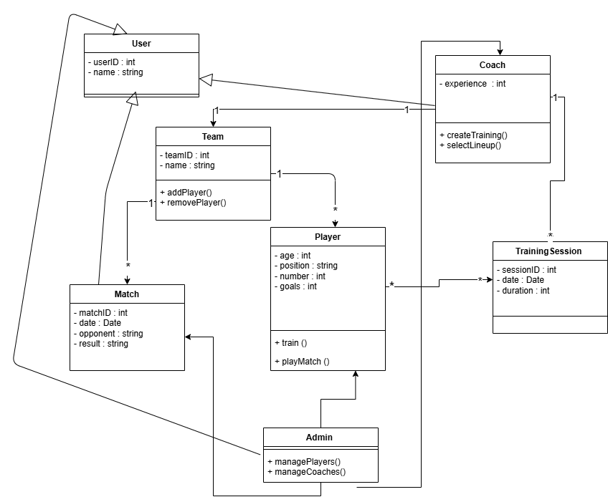
Figure 1: Inheritance Relations

  - Class descriptions

Class name
PLAYER

List of Superclasses:

User

List of Subclasses:
None

Purpose:
Represents a football player in the system and stores player-related information.

Collaborations:

- Team: Player belongs to a team
- TrainingSession: Player participates in training sessions
- Match: Player plays matches

Attributes:

- age : int (e.g., 18–40)
- position : string (e.g., Forward, Defender)
- number : int (e.g., 1–99)
- goals : int (e.g., 0–100)

Operations
train()
- Arguments: None
- Return: void
- Description: Player participates in training
playMatch()
- Arguments: None
- Return: void
- Description: Player plays a match

Constraints:

- Player must belong to only one team
- Player age must be greater than 16

  - Class descriptions

8.3.1 Class name
ADMIN

8.3.2 List of Superclasses:
USER
8.3.3 List of Subclasses:
NONE
8.3.4 Purpose:
Manages system operations and data.

8.3.5 Collaborations:
- Player: Manage players
- Coach: Manage coaches
- Match: Manage matches

8.3.6 Attributes:
- No additional attributes

8.3.7 Operations
- managePlayers()
  - Arguments: None
  - Return: void
  - Description: Add, delete, update players
- manageCoaches()
  - Arguments: None
  - Return: void
  - Description: Manage coaches

    - Constraints:
- Admin must be authenticated

8.4 Class descriptions

8.4.1 Class name
TEAM
8.4.2 List of Superclasses:
NONE
8.4.3 List of Subclasses:
NONE
8.4.4 Purpose:
Represents a football team.

8.4.5 Collaborations:
- PLAYER: Contains players
- COACH: Managed by coach
- MATCH: Participates in matches
8.4.6 Attributes:
- teamID : int
- name : string
8.4.7 Operations
addPlayer()
- Arguments: Player
- Return: void
removePlayer()
- Arguments: Player
- Return: void

8.4.8 Constraints:
- Team must have at least one player

8.5 Class description
8.5.1 Class name
USER

8.5.2 List of Superclasses:
NONE

8.5.3 List of Subclasses:
PLAYER, COACH, ADMIN

8.5.4 Purpose:
Represents a general user of the system and provides common attributes and operations.

8.5.5 Collaborations:
Player, Coach, Admin: Inherited by them
8.5.6 Attributes:
- userID : int (e.g., 1–1000)
- name : string (e.g., "Ahmed")
8.5.7 Operations

8.5.8 Constraints:
userID must be unique.
8.6 Class descriptions

8.6.1 Class name
MATCH
8.6.2 List of Superclasses:
NONE
8.6.3 List of Subclasses:
NONE
8.6.4 Purpose:
Represents a football match.

8.6.5 Collaborations:
- Team: Teams play match
- Player: Players participate

8.6.6 Attributes:
- matchID : int
- date : Date
- opponent : string
- result : string

8.6.7 Operations

8.6.8 Constraints:
Match must have two teams
8.7 Class descriptions

8.7.1 Class name
COACH
8.7.2 List of Superclasses:
USER
8.7.3 List of Subclasses:
NONE
8.7.4 Purpose:
Represents a coach responsible for training and managing the team.

8.7.5 Collaborations:

- Team: Manages team
- TrainingSession: Creates training

8.7.6 Attributes:
- experience : int (1–30 years)
8.7.7 Operations
- createTraining()
  - Arguments: date, duration
  - Return: void
  - Description: Creates training session
- selectLineup()
  - Arguments: None
  - Return: void
  - Description: Selects players for match

8.7.8 Constraints:
- Coach must be assigned to one team

8.8 Class descriptions

8.8.1 Class name
TrainingSession

8.8.2 List of Superclasses:
NONE
8.8.3 List of Subclasses:
NONE
8.8.4 Purpose:
Represents a training session.

8.8.5 Collaborations:
- Coach: Creates session
- Player: Attends session

8.8.6 Attributes:
- sessionID : int
- date : Date
- duration : int

8.8.7 Operations
NONE
8.8.8 Constraints:
- Session must have assigned coach

Operational Scenarios
Scenario 1: Add Player
- Admin logs into the system
- Admin selects "Add Player"
- Admin enters player details
- System validates data
- Player is added successfully

Scenario 2: Schedule Match
- Admin logs in
- Selects "Schedule Match"
- Enters match details
- System saves the match

Preliminary Schedule Adjusted

Task | Duration
SRS | DAYS 2
DESIGN DIAGRAMS | DAYS 3
IMPLEMENTATION | DAYS 5

Preliminary Budget Adjusted

This project does not require any financial budget as it is an academic project.

Appendices

  - Definitions, Acronyms, Abbreviations
- Player: Football team member
- Coach: Team trainer
- Admin: System manager

  - Collected material

No additional material.

References References
No external references used.

